To create a Razorpay API key for integration with the Ecera Training App, follow these steps:

#### First Sign Up:

#### Navigate to API Keys:

After successful registration, go to the home page.

Access Accounts & Settings:

From the home page, navigate to the "Accounts & Settings" section in the left sidebar.

-  
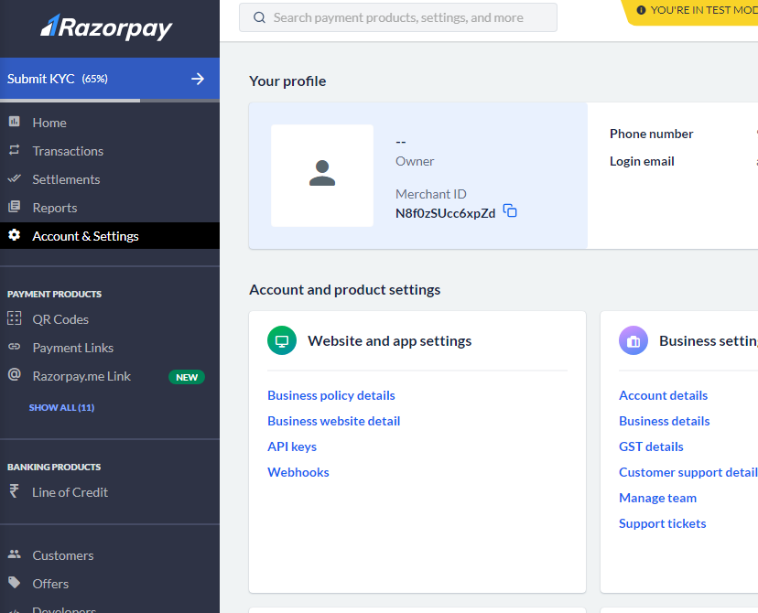

Go to API Keys Tab:

Inside the "Accounts & Settings," go to the "API Keys" tab.

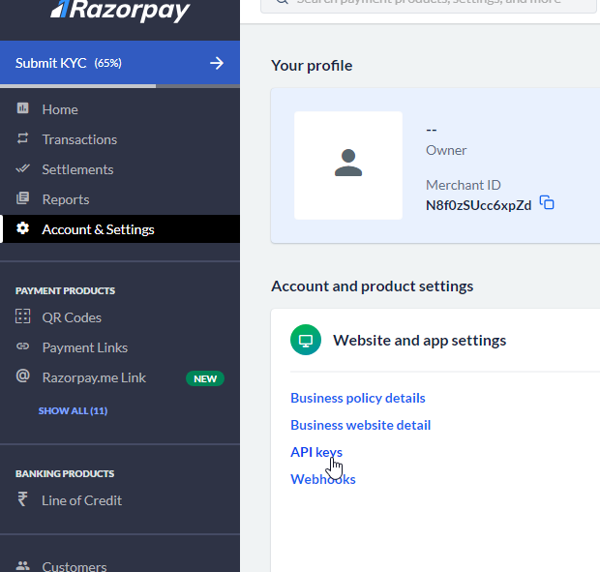

#### Retrieve Razorpay Key:

Inside the "API Keys" tab, you will find the RAZORPAY_KEY_ID and RAZORPAY_SECRET_KEY. Please note down the RAZORPAY_SECRET_KEY as it is shown only once.

#### Integrate API Key in Ecera Training App:

In the server folder, locate the .env file (server\.env). Update the RAZORPAY_KEY_ID and RAZORPAY_SECRET_KEY with the keys you obtained.

-  
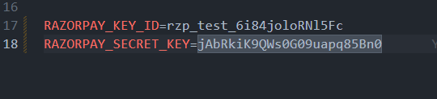

-

-  
In the client folder, locate the .env file (client\.env). Update the RAZORPAY_KEY_ID with your created ID.

-

-



#### Track Payments and Transactions:

To track your payments and transactions, navigate to the "Transactions" section in the left sidebar. Here, you can view all payments.

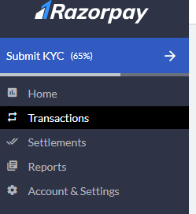

-

-  
From left sidebar, Transactions section you can see all the payments

-

-







